|  |  |  |  |  |  |
| --- | --- | --- | --- | --- | --- |
| Date | 9-Dec-22 | | | Tester Name | Mohammad Yusuf |
| Environment | Penfax - Test | | | Login used |  |
| Operating System | Windows | Version: | Update: | | |
| Software Used | Select Software | Version: | Update: | | |
| Select Software | Version: | Update: | | |
| Release version |  | | | | |
| Title |  | | | | |
| Test Type | Regression | | | | |
| Test Scenario |  | | | | |
|  |  | | | | |
| Expected Results |  | | | | |
| Pass/Fail | Select | | | JIRA# | N/A |

Describe your steps with screenshots:

|  |
| --- |
| In Penfax search for the member.  Click on the stakeholder ID |
| Go to DC Benefit Selection Click +Add |
| Input a Retierment date of today Then click Next Under Allocation click +Add |
| Under Fund Select a fund from the dropdown list Under contribution type Select All(If all is not an options select one type Under Allocaiton method select Percent Under Percentage input 100 Under Transfer Vehilce select Variable Pension Benefit Account Click Save |
| Click Next Click Submit for Approval |
| Click Approve |
| Wait for overnight Batch processes to run |
| Go to Commication Under Outbound Documents there should be a PDF Welcome to VPB letter saved and accessible |
| Go to the Investments Tab There should be a new Investment account of VPB.  The balance in the VPB should be full Transction histroy should display the transfer in |
| In the Investment tab the PEPP account should be now account status inactive.  The balance should be 0. And the account activity should show the transfer to the VPB |

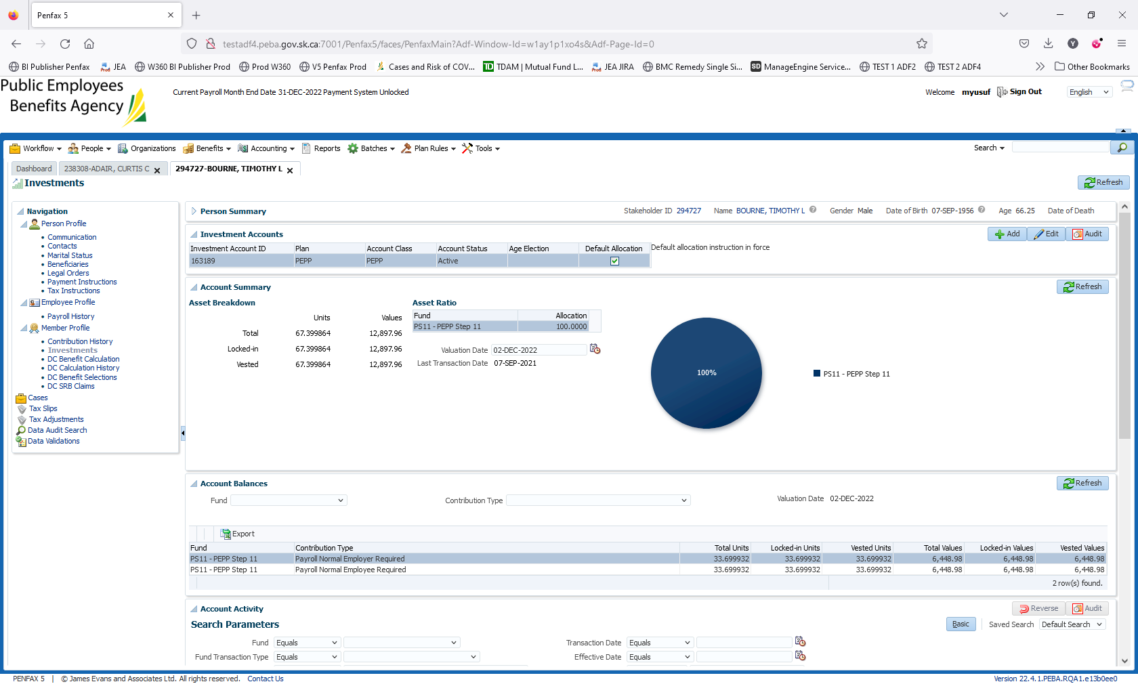

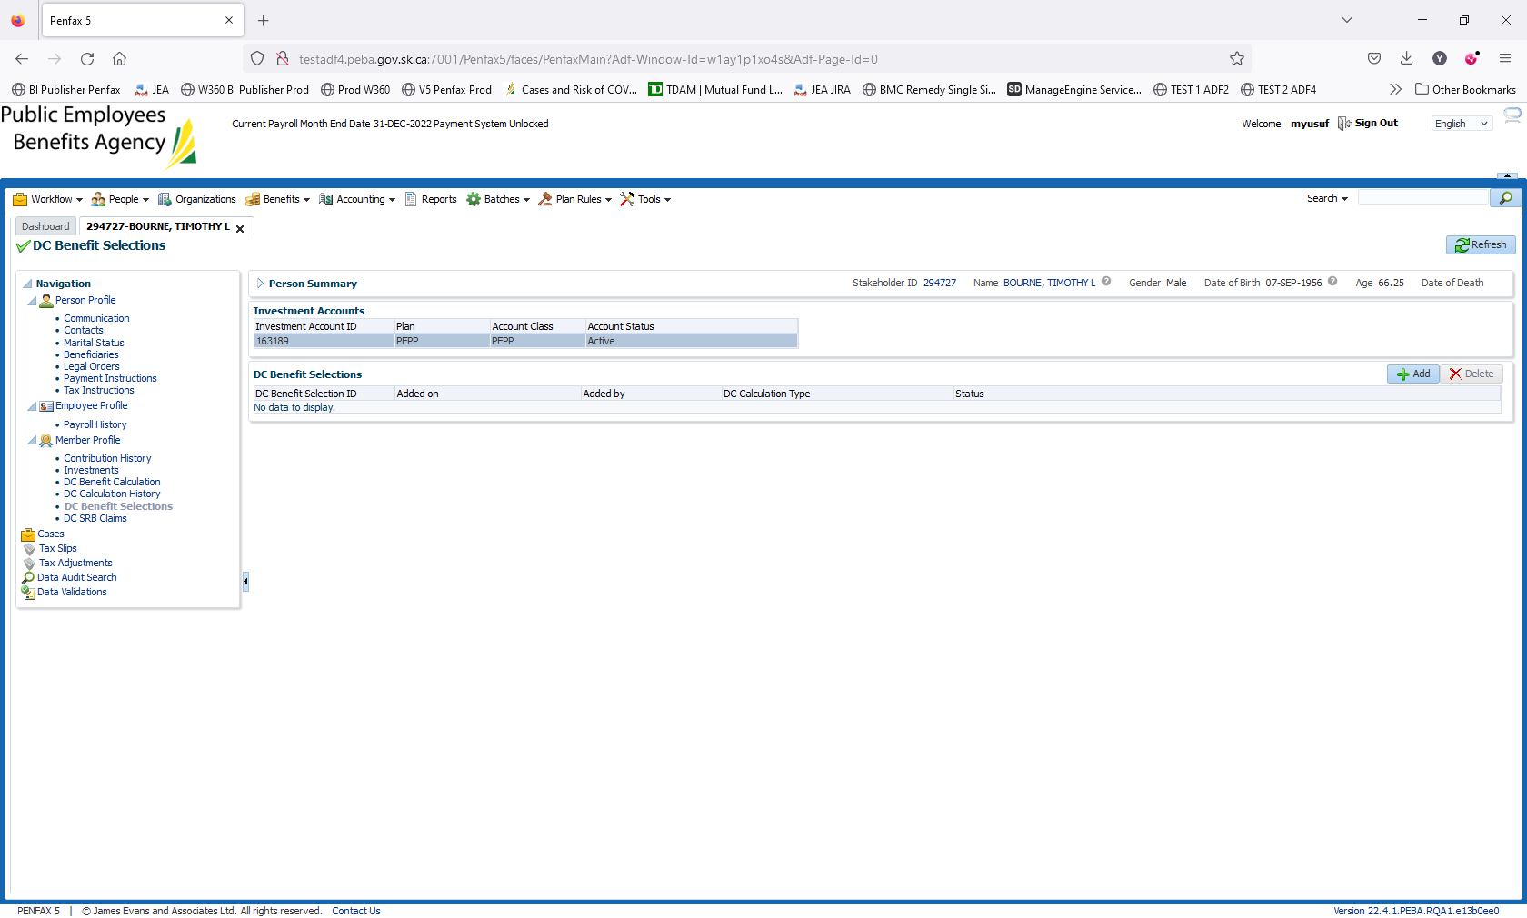

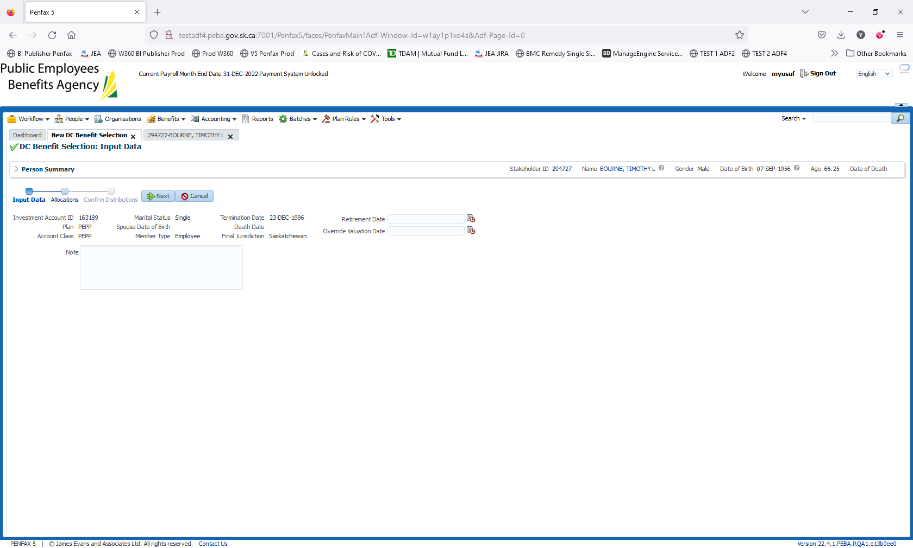

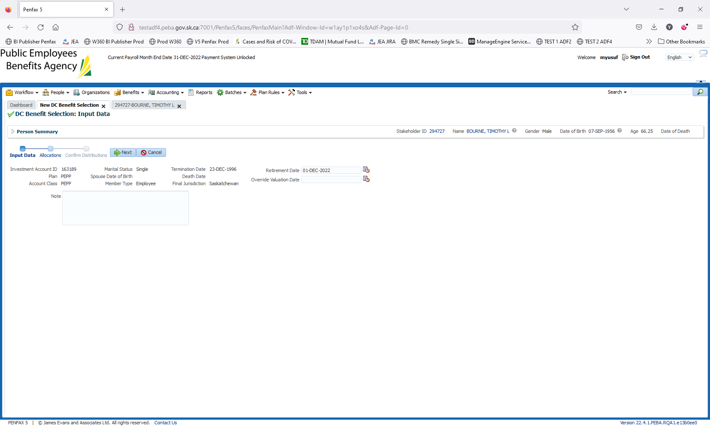

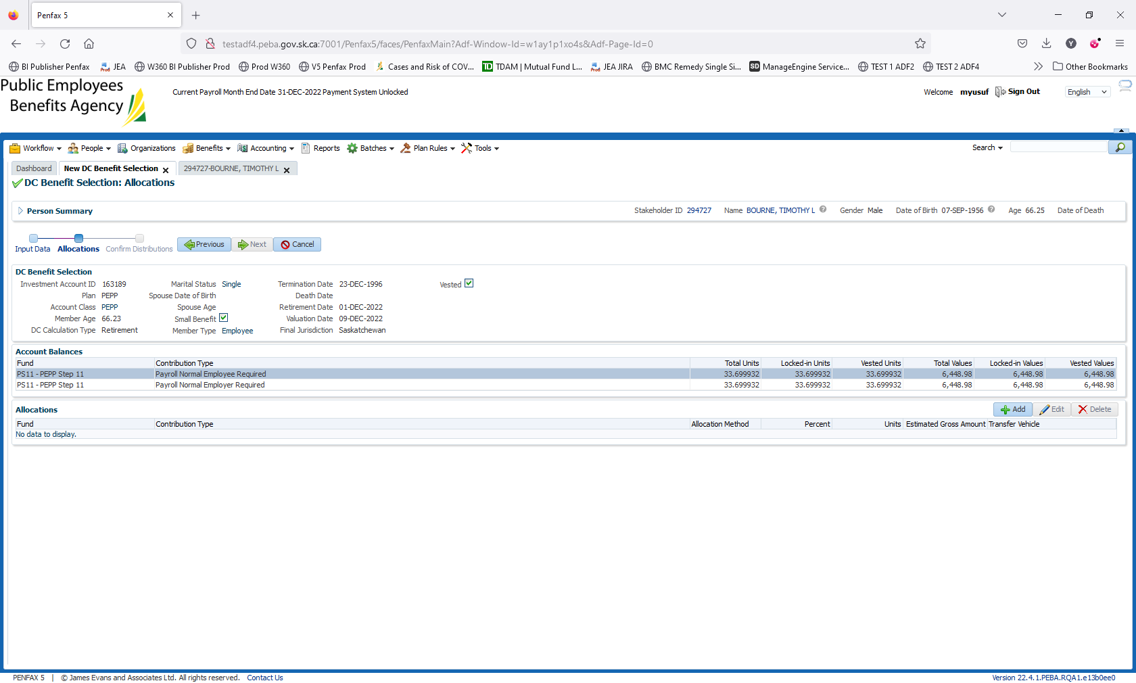

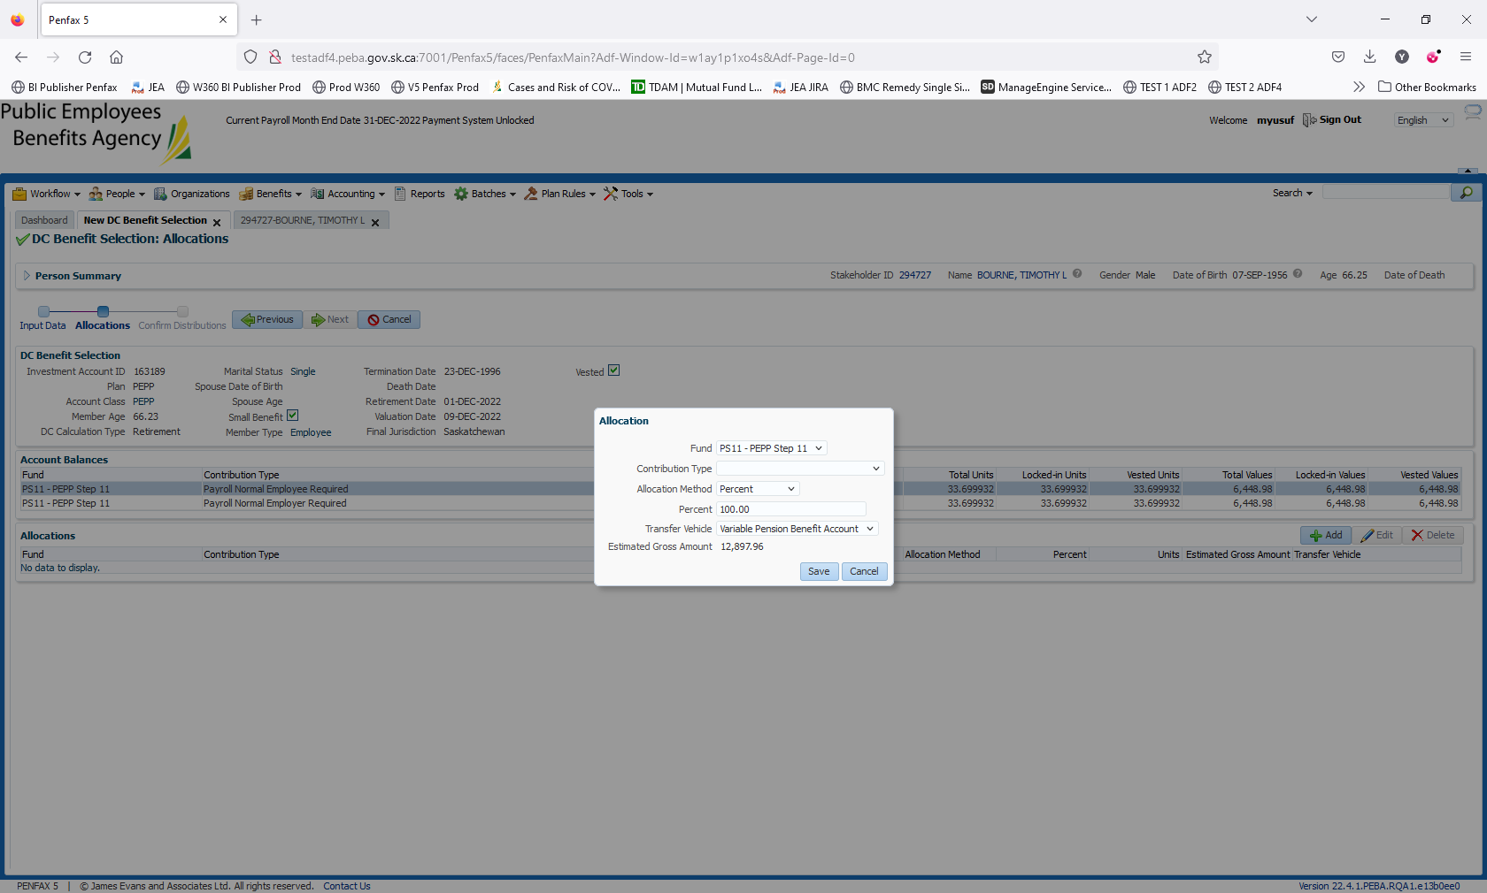

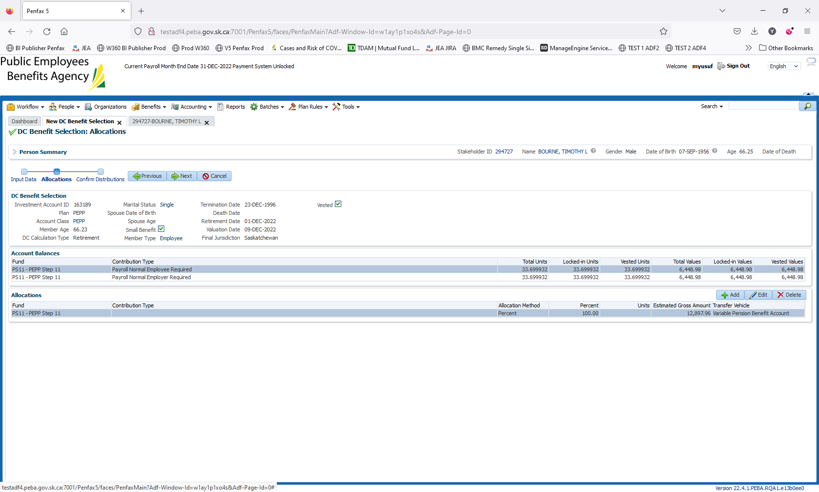

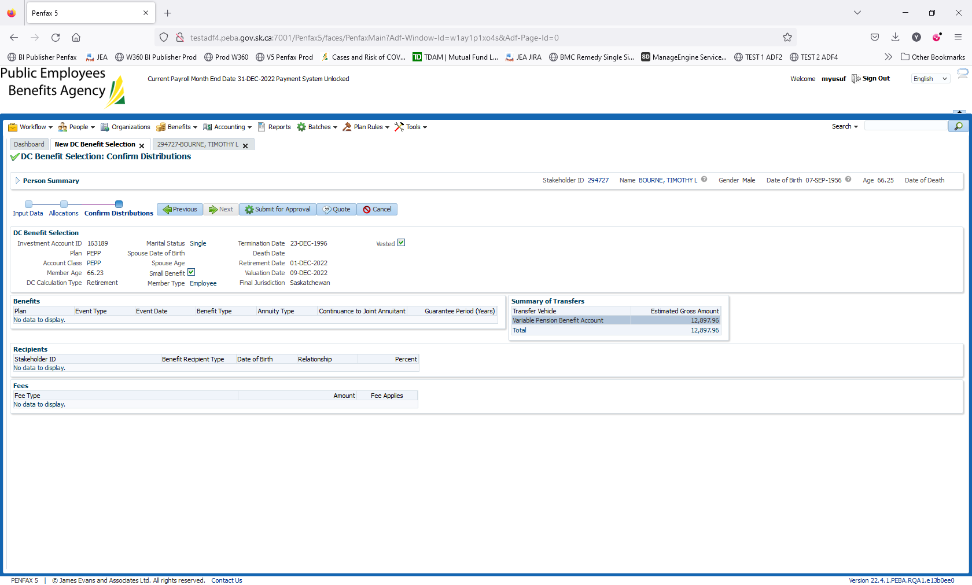

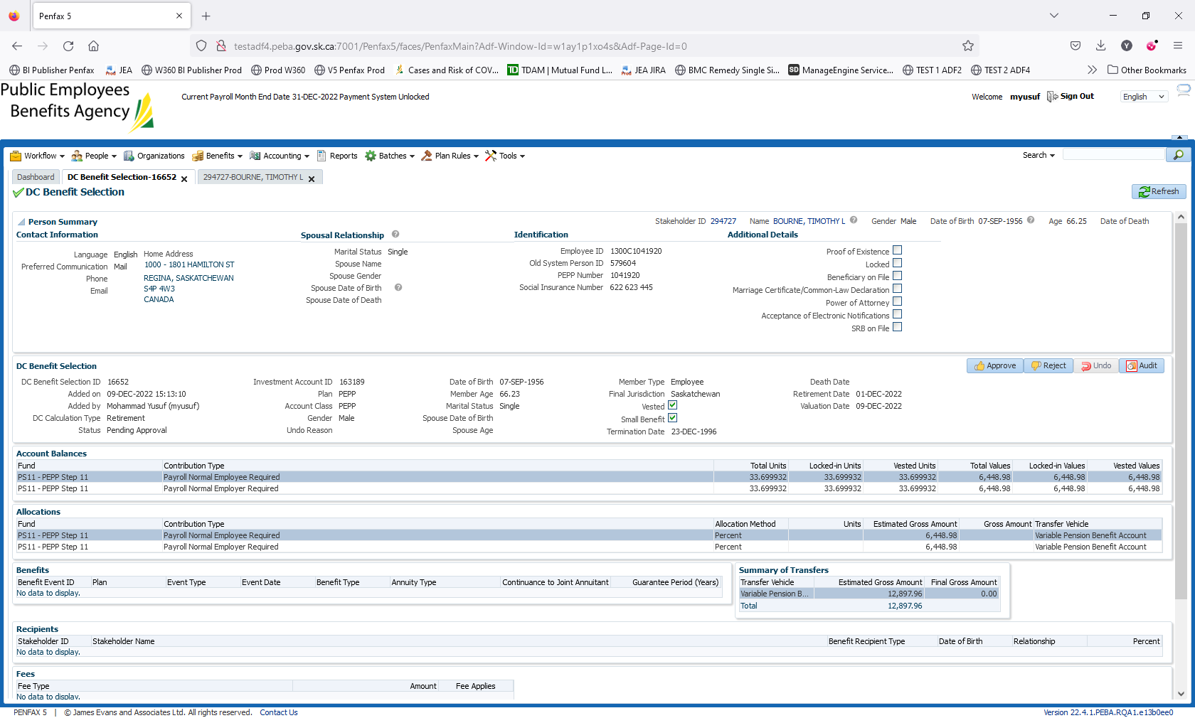

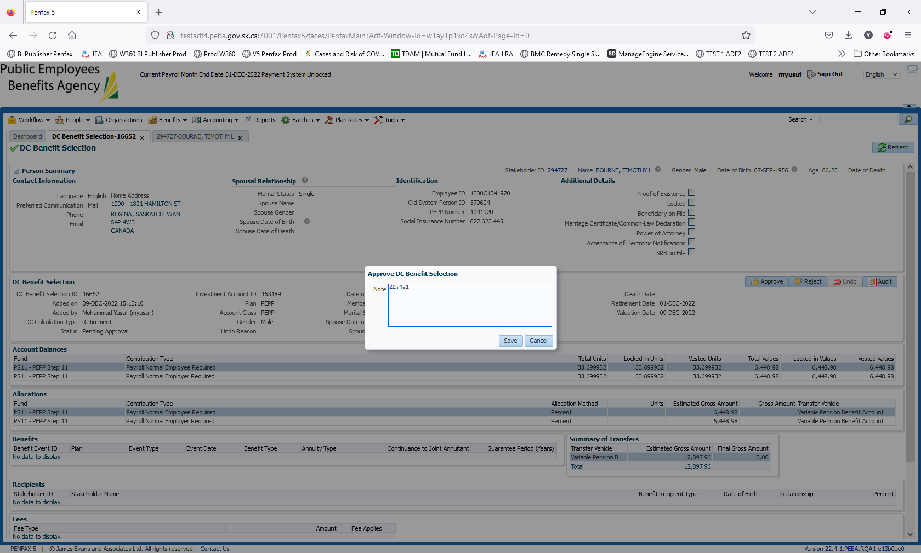

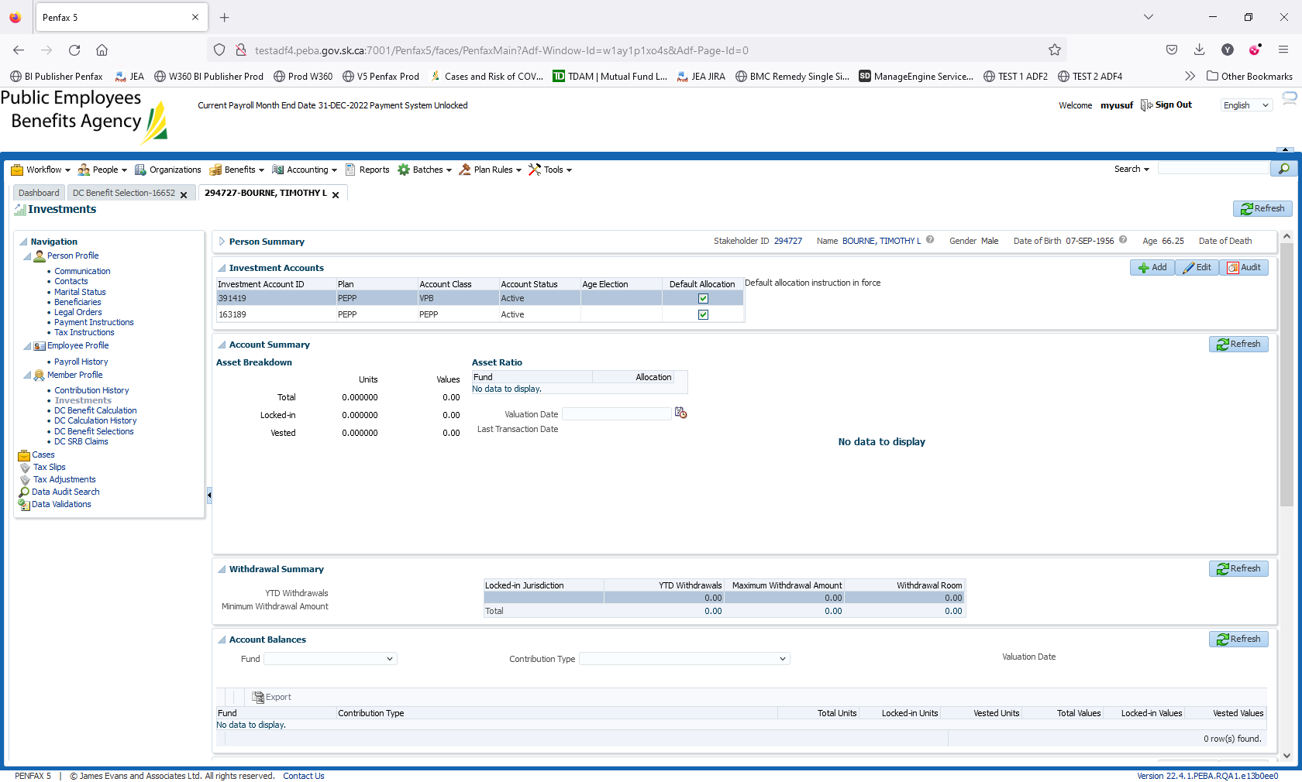

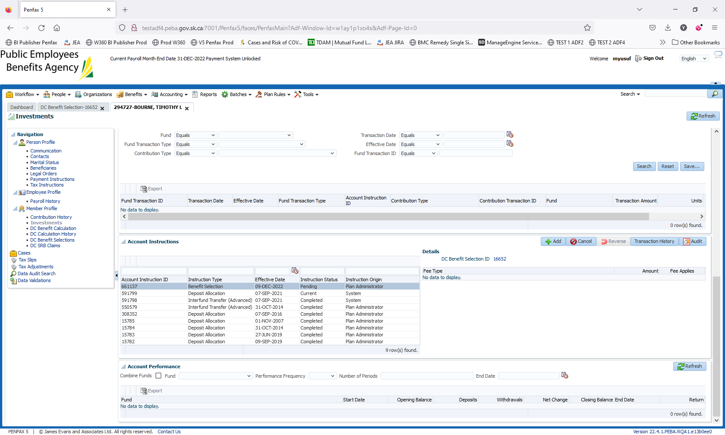

Day 2 Validation

